Creating a Signature in Windows Desktop Outlook

Being a New Email
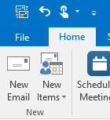

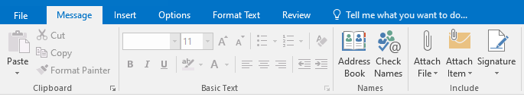
Select Signature from Ribbon and Signatures from the drop down

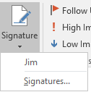

(I have an existing signature names Jim)

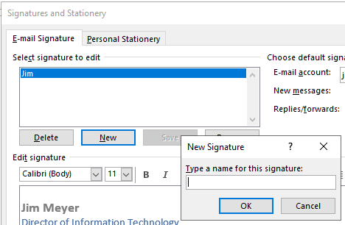

Click New and type in name for your signature and Select OK

In the Edit signature box type in your signature (Tip: You can copy and paste your signature from a previous email into this box)

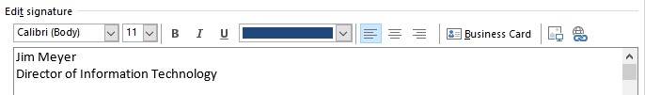

You can change the font of your signature. At the far right of the Edit signature box you can use the add picture button to insert a logo or another picture.

Once you have completed your signature, you can setting the default for when your signature is automatically inserted. My default below will have my signature automatically appear in New messages, but not in Replies/forwards.
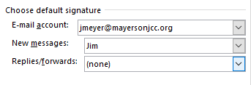
Select OK when done.

To manually add an existing signature

Select Signature from the Ribbon and the existing signature name (in my case Jim)

